Pixel Renderer Manual

# McKinley Grimes

Table of Contents

Contents

McKinley Grimes 1

1. Introduction 3

2. Getting Started 3

3. Painting Frames 5

4. Analyzing Frames 7

5. Comparing Frames 8

6. Load Reference 10

# 1. Introduction

This paper is a manual on the features of the FS4500 PixelRenderer Software paired with the Probe Manager. The features of the PixelRenderer include:

* Painting frames from Probe Manager
* Analyze Frames and Output Number of Pixels on each line
* Comparing Frames and Spotting Difference
* Load jpec from personal computer for purpose of being compared to captured frames from the Probe Manager.

# 2. Getting Started

The user will be presented with this form when launching the application.

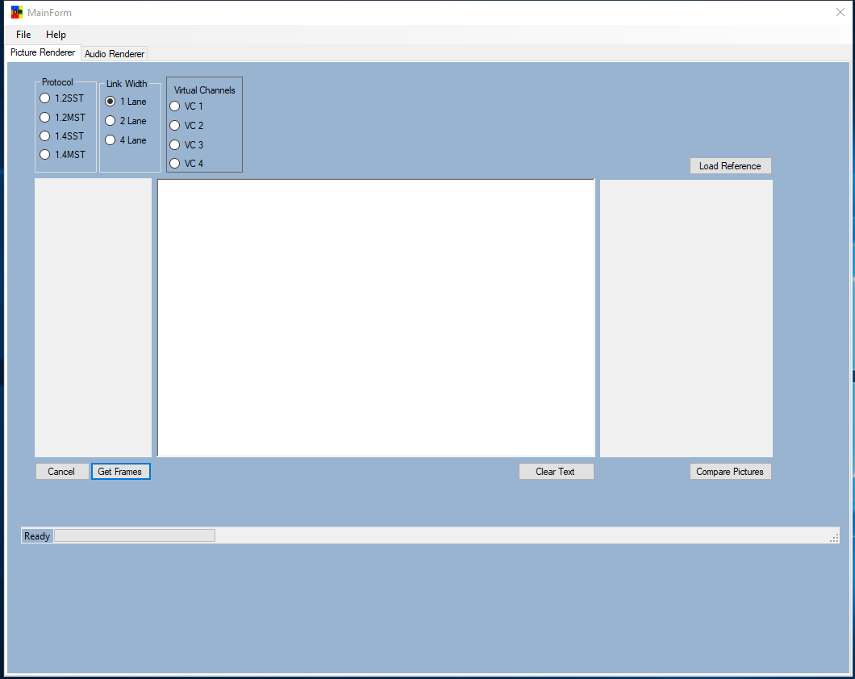

The Probe Manager must be opened in order for this software to work, like shown below.

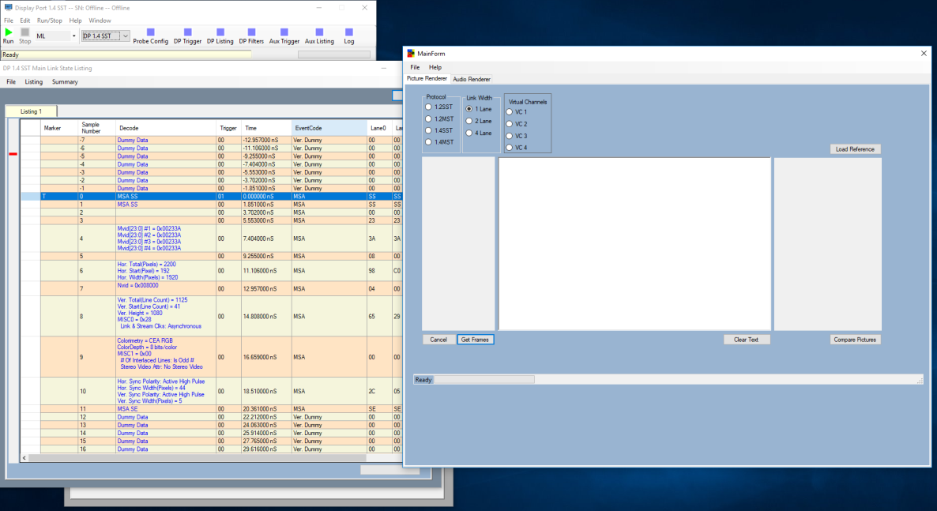

The configuration that is loaded in the Probe Manager is the same data that the Pixel Renderer is seeing. If the Probe Manager is not open, an error will appear when the user clicks the Get Frames button.

It will be up to the user to input the Protocol, Link Width, and Virtual Channel. If either SST protocol is selected, the virtual channel will default to VC1. After the user has selected the Protocol, Link Width, and Virtual Channel, the Get Frames button can be clicked.

When clicked, the software will go through the entire data file and count each complete frame that is found. Each counted frame will be presented in the panel above the Get Frames button as shown.

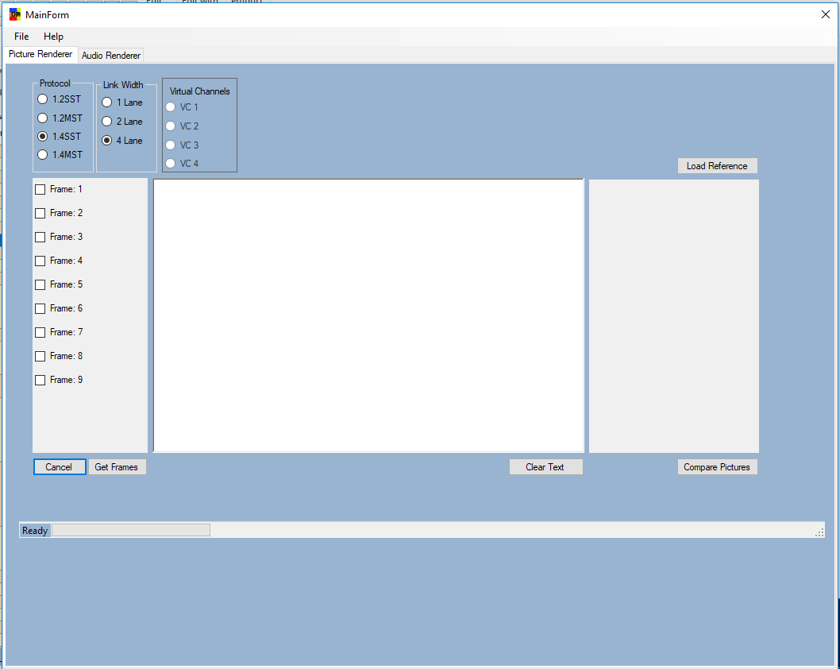

Whenever the Get Frames button is clicked, anything that was previously in the panel above will be cleared out and the number frames will be added in. This means that if the user is finished with one file and wants to load a new configuration into the Probe Manager to test, they can do so. The Cancel button is used when the user wants to cancel the command to Get Frames.

# 3. Painting Frames

After the frames have been found the user may select any of the check boxes and a picture renderer form will popup.

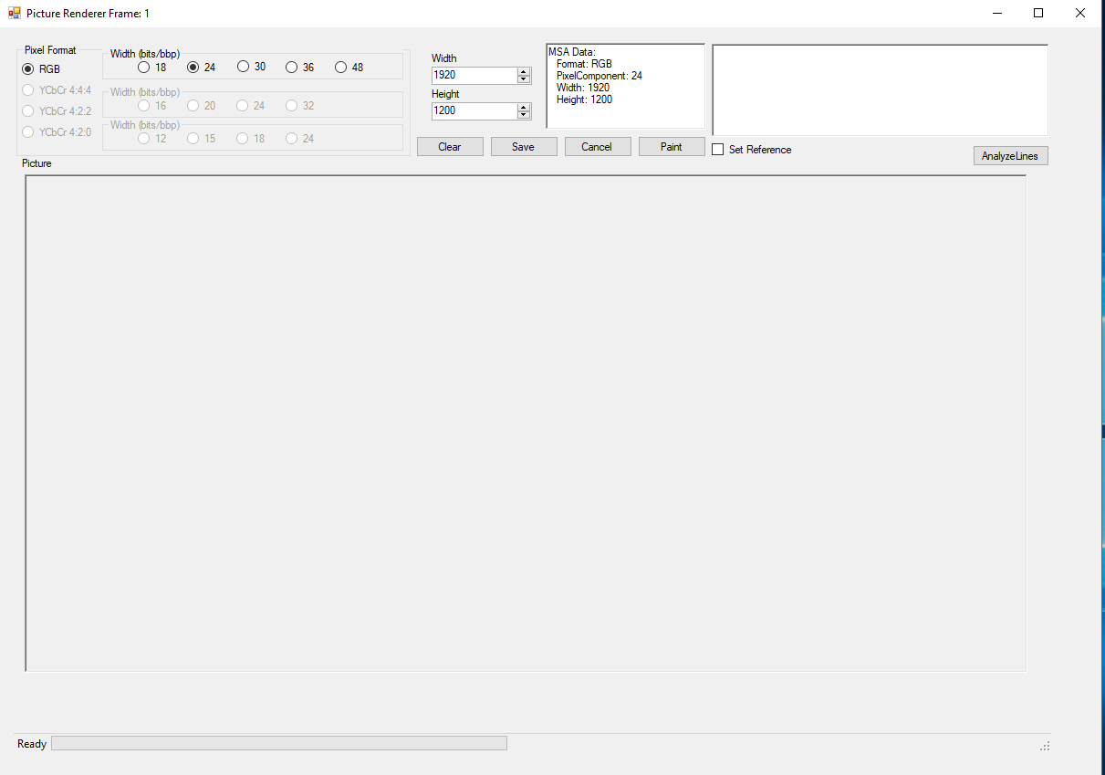

While the software was counting the frames, it extracted the MSA Data and the settings have been set to represent the MSA Data. When the user clicks the paint button, the picture will beginning painting and will be shown when finished.

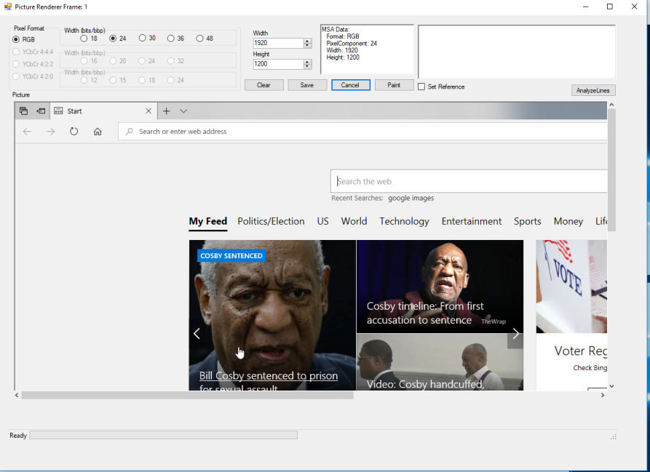

Multiple Pixel Renderers can be popped up at the same time.

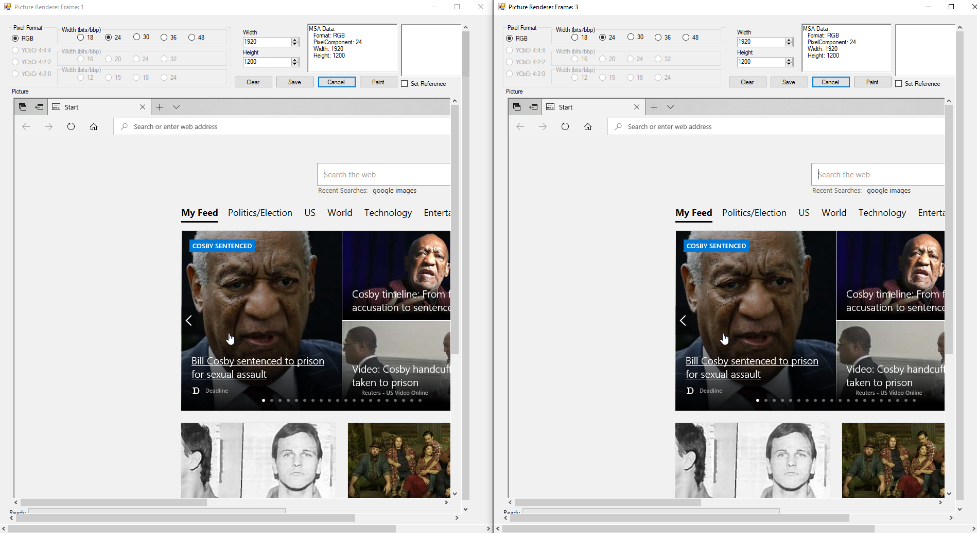

Even though multiple pixel renderers can be popped up at the same time, only one can paint at a time. The user will be able to distinguish which frame is which by looking at the title of the form at the top.

The Cancel button is used if the programs for whatever reason is taking too long to paint or freezes. When the paint button is clicked, the other buttons on all other pixel renderer forms and the main form are disabled until the picture is finished painting. The Cancel button will enable the forms again and cancel the paint request.

The Save button will allow the user to save whatever is in the picture box as a jpec to their computer. The Clear button will clear the picture box.

# 4. Analyzing Frames

The AnalyzeLines button will go through the frame, count the number of pixels for each line of the frame, show if there were any errors for each line, and show the start state and end state of each line to allow the user to refer back to the state listing in the Probe Manager.

The picture will still paint when AnalyzeLines is clicked but it will paint whatever data it has. This is different than the Paint button because if there is an error while the Pixel Renderer is painting, the program will stop and output the error. If analyzing, the program will paint whatever it sees.

The data will be shown in the text box above the Analyze Lines frame.

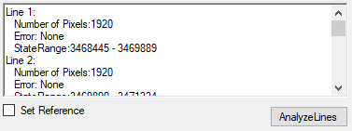

# 5. Comparing Frames

When a picture is painted through the paint button, there will be an option on the main form to compare the pictures of each frame the user has painted.

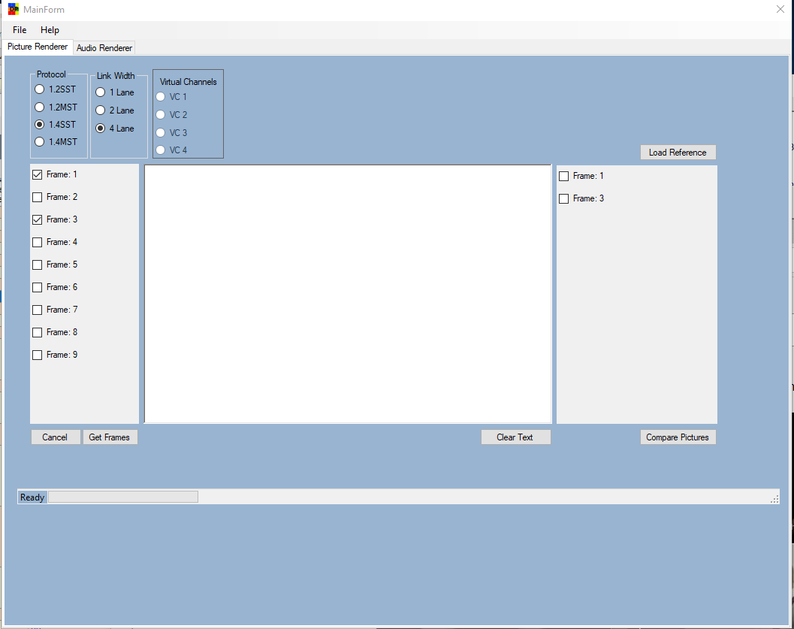

These are the same pictures that were shown above in the Painting Frame section of this document. The user can select the two frames and click Compare Pictures. If the pictures are the same, a message will appear telling they are the same.

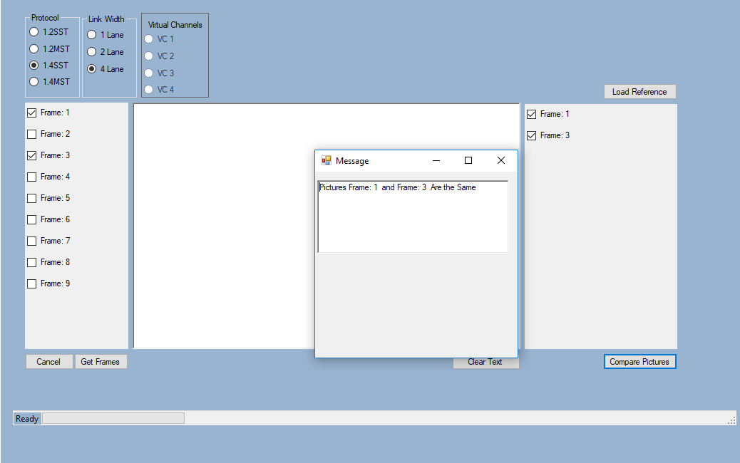

The compare pictures will only compare two frames, and the pictures must have the same number of pixels, or an error will appear. If there are any differences, a table will be created in the text box to the left to show which pixels were different.

In order for this document to show what will appear when the frames are different, a new configuration file will be loaded. In this new file, frames 1 and 3 have been painted and are shown below. 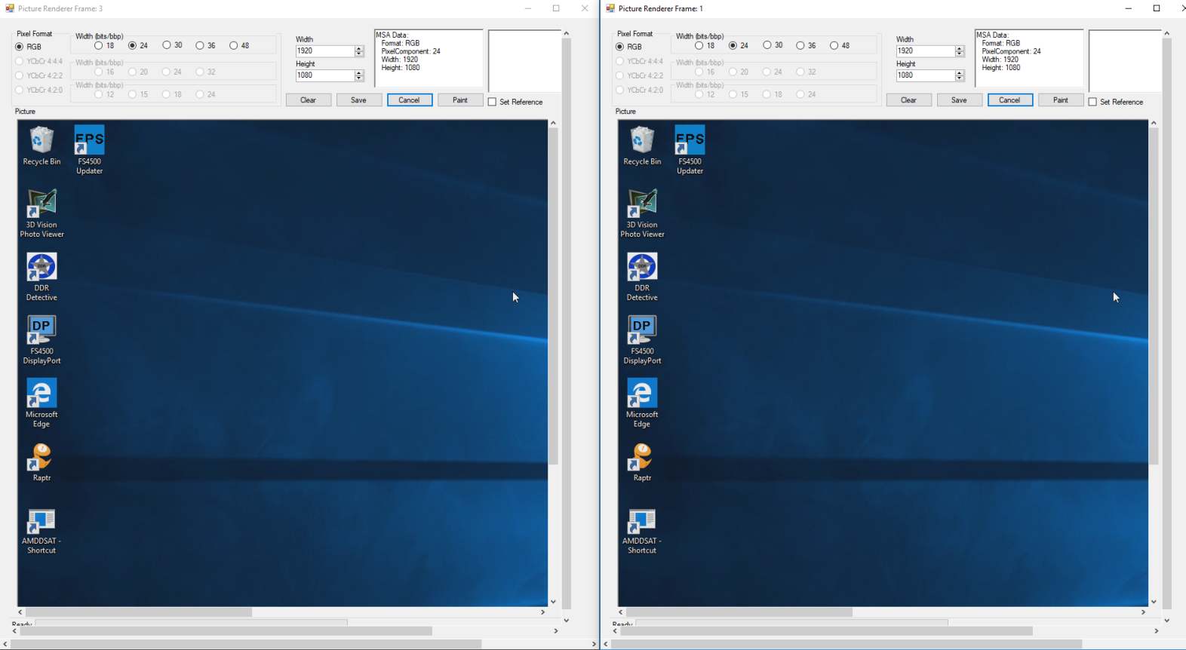

They might appear the same, but when the pixels are compared, differences will be shown. Below is the result when these two pictures are compared.

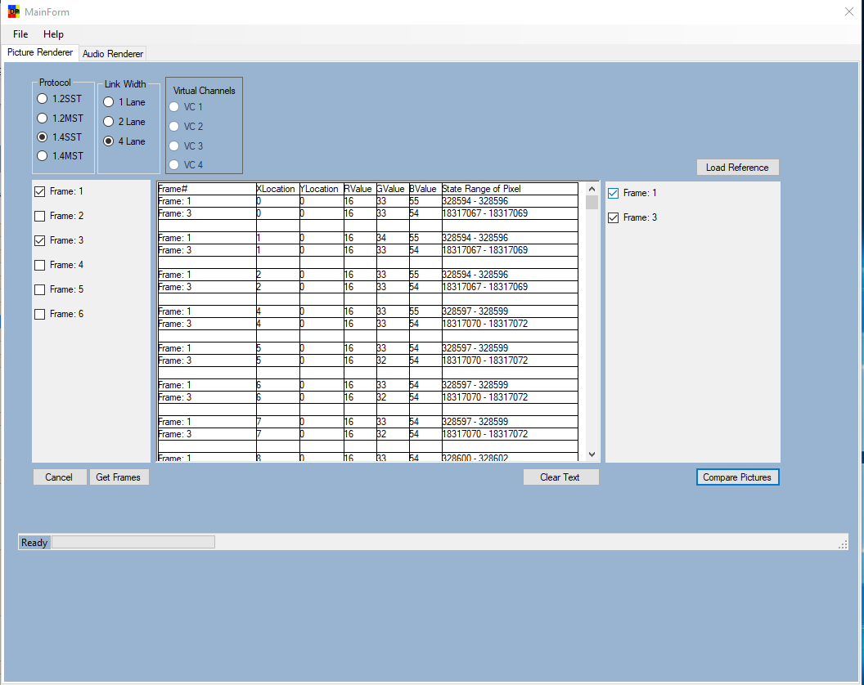

The table outputs all the pixels that are different between the two frames and will show the X and Y location, and RGB Values. The State Range of the Pixel is shown as well so the user can refer back to state listing and know which states refer to that particular pixel.

The program will time out when it sees 10,000 pixels that are different due to memory constraints, however, as shown, the pixels have very minor differences. The program will capture any major to minor difference in the RGB value and output that pixel into the table. The user can click Clear Text in order to clear the table.

# 6. Load Reference

The user can add their own pictures if they would like to compare to the Probe Manager data. When the Load Reference button is clicked, a browse window will appear.

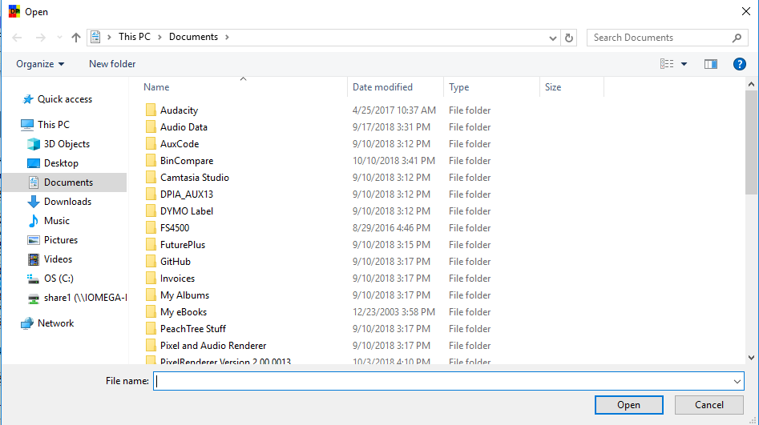

The user can search through his personal machine and select a picture, that picture will be loaded into the software and ready to be selected for compare. The picture will be labeled Reference in bold.

